DATA WAREHOUSING AND DATA MINING

Lab programs:

1.In a class of 10 students , the time taken by each student is given below:

5,2,10,0,9,8,2,1,0,0.

calculate Mean ,Median and Range for the following data.

OUTPUT:

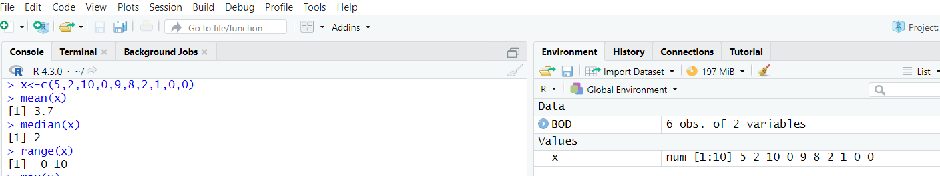

2. Suppose that the data for analysis includes the attribute age. The age values for the data tuples are (in increasing order) 13, 15, 16, 16, 19, 20, 20, 21, 22, 22, 25, 25, 25, 25, 30, 33, 33, 35, 35, 35, 35, 36, 40, 45, 46, 52, 70.

(a) What is the mean of the data? What is the median?

(b) What is the mode of the data? Comment on the data’s modality (i.e., bimodal, trimodal, etc.).

(c) What is the midrange of the data?

(d) Can you find (roughly) the first quartile (Q1) and the third quartile (Q3) of the data?

OUTPUT:

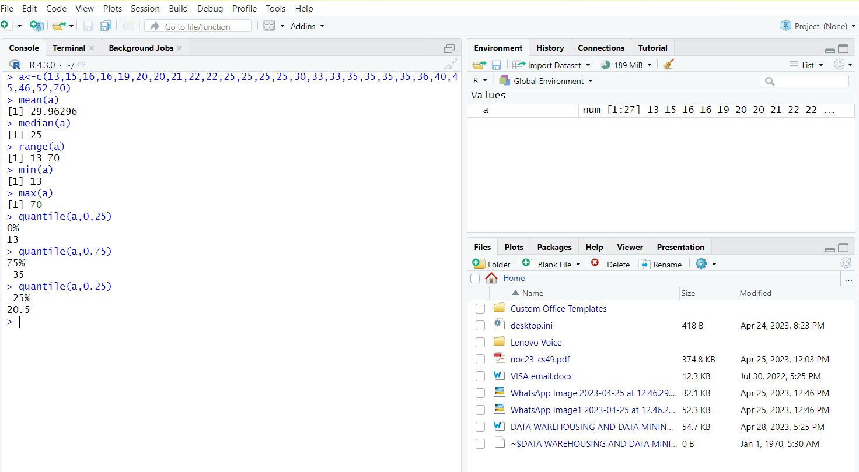

3.Calculate mean,median and Range for the Precompiled data in R programming

OUTPUT:

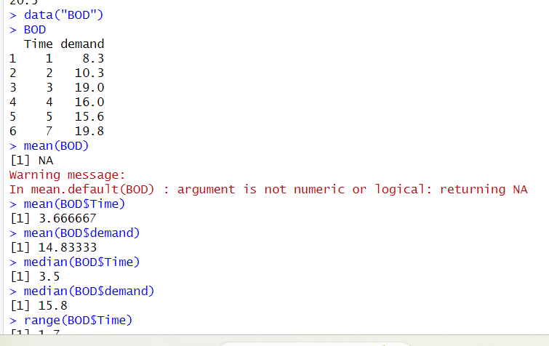

4. The intervals and corresponding frequencies are as follows. age frequency

1-5 200 5-15 450 15-20 300 20-50 1500 50-80 700 80-110 44

Compute an approximate median value for the data.

OUTPUT:

